**Assignment 2**

**Name: Humza Ashraf Roll No. 19-11217**

**Submitted to: Madam Saba Khalil Toor**

**Course: Software Engineering Comp 220**

**Section: A**

**Online Supermarket Software**

**Functional Requirements**

* Keeping the records of products received & daily sales.
* Keeping records of returned items.
* Sale chart of each item sale and returned for admin understanding.
* Storing the feedback given by the customer.
* Tracking of Customer order until it is delivered.
* Cart Items stored in temporary storage until
* Online Receipt for Customer Use.

**Non Functional Requirements**

* Secure Transaction for Customers
* Easy to understand and use software
* 512 MB RAM requirement
* Compatible with all Operating Systems.
* Good speed internet of user.
* Have a high speed server.
* Non ethical comments by user should result in account blocking.

**WBS Diagram**

**AON Diagram**

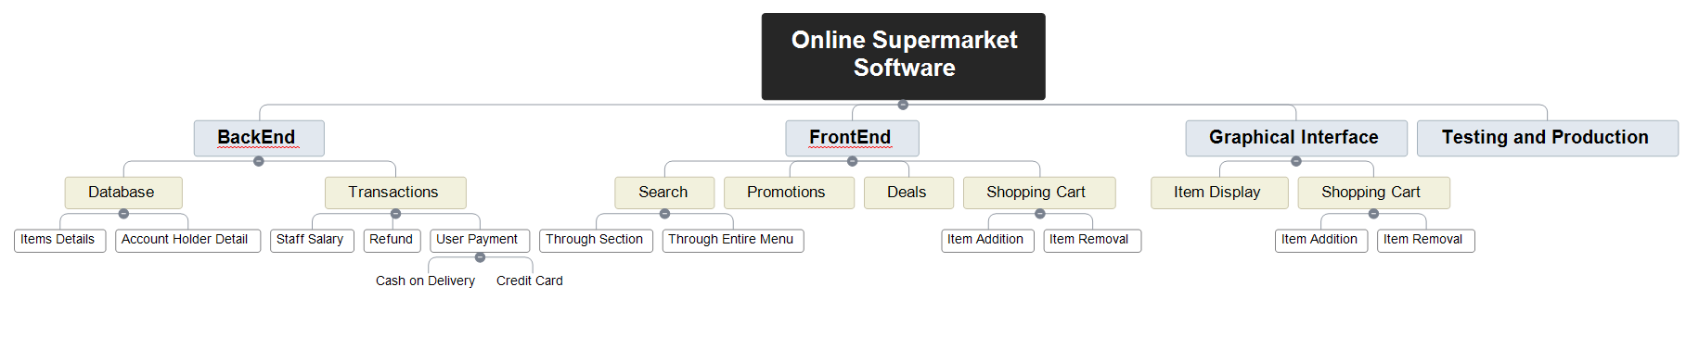

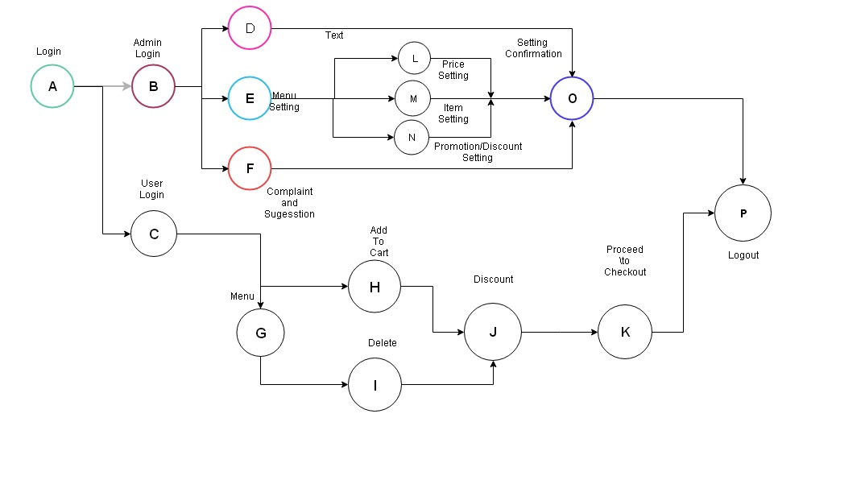

**Gantt Chart**

